# In Zabbix, create admin users with their email addresses by following these steps:

## Step 1 - Login to Zabbix Web Interface:

Open your web browser and access the Zabbix web interface by entering the URL of your Zabbix server (http://10.50.105.188/zabbix). Log in using your admin credentials.

## Step 2 - Navigate to User Management:

Once logged in, click on "Administration" in the top menu, then select "Users."

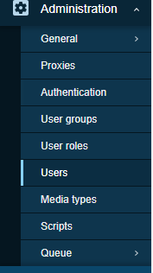

## Step 3 - Create a New User:

Click on the "Create user" button to start creating a new user.

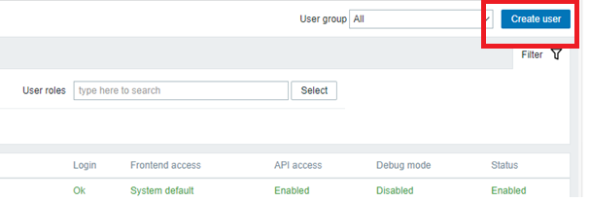

## Step 4 - User Configuration:

Fill in the user details, including their name, alias, and other relevant information. In the "Media" tab, you can add an email address for the user.

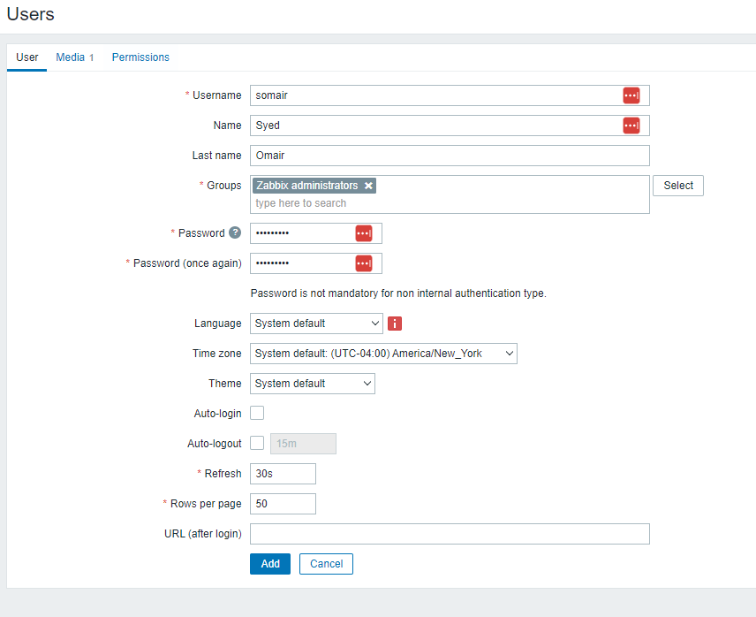

## Step 5 - Add Email Address:

In the "Media" tab of the user creation form, click on "Add" to add a new media for the user. Choose "Email" as the media type. Enter the user's email address in the "Send to" field. You can also configure other options related to email notifications, such as the severity of events to be notified about.

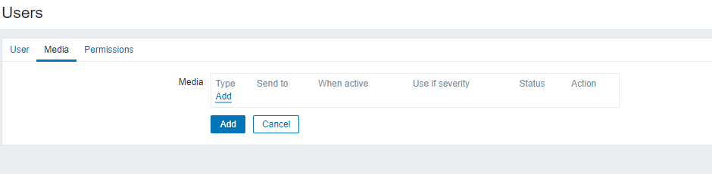

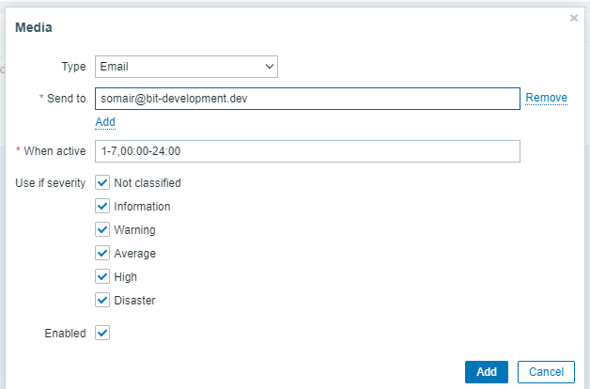

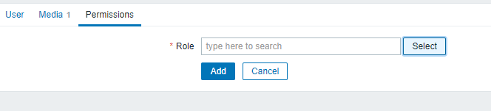

## Step 6 - User Group and Permissions:

In the "Groups" tab, assign the user to the appropriate user group. Typically, administrators are part of the "Zabbix administrators" group. Set the necessary permissions based on your requirements.

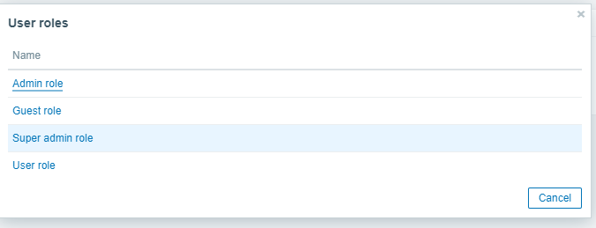

## Step 7 - Save the User:

After configuring the user details, email address, groups, and permissions click on the "Add" button to create the user.

